Create service limit-service –will read values from centralized git repo using spring cloud config server which runs at port no 8888

In app.properties

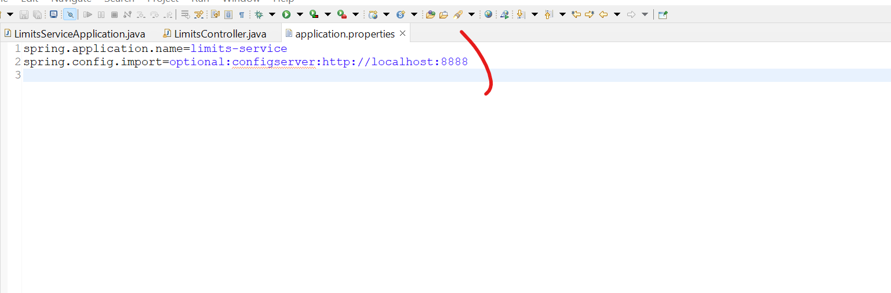

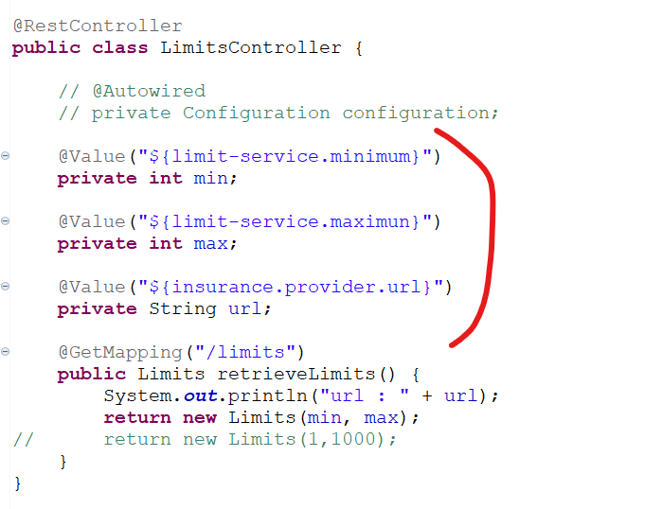

@ConfigurationProperties

Used to read value from application.properties

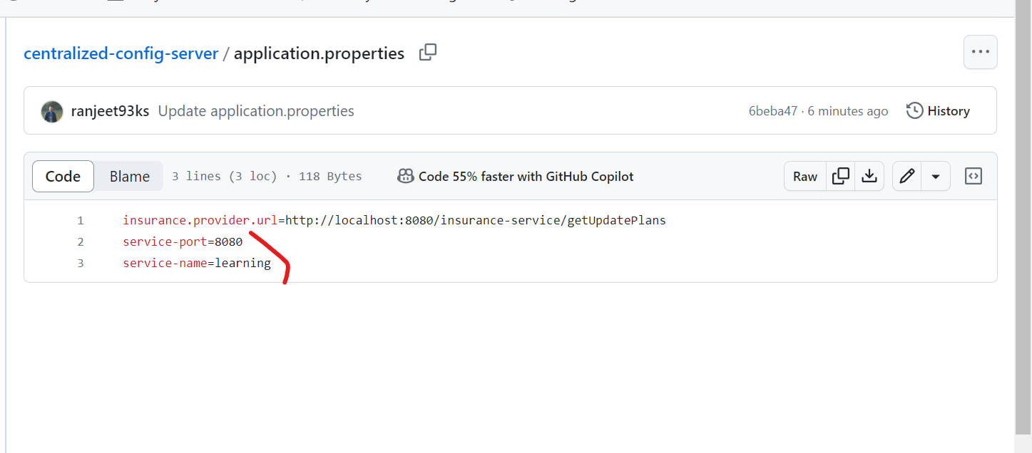

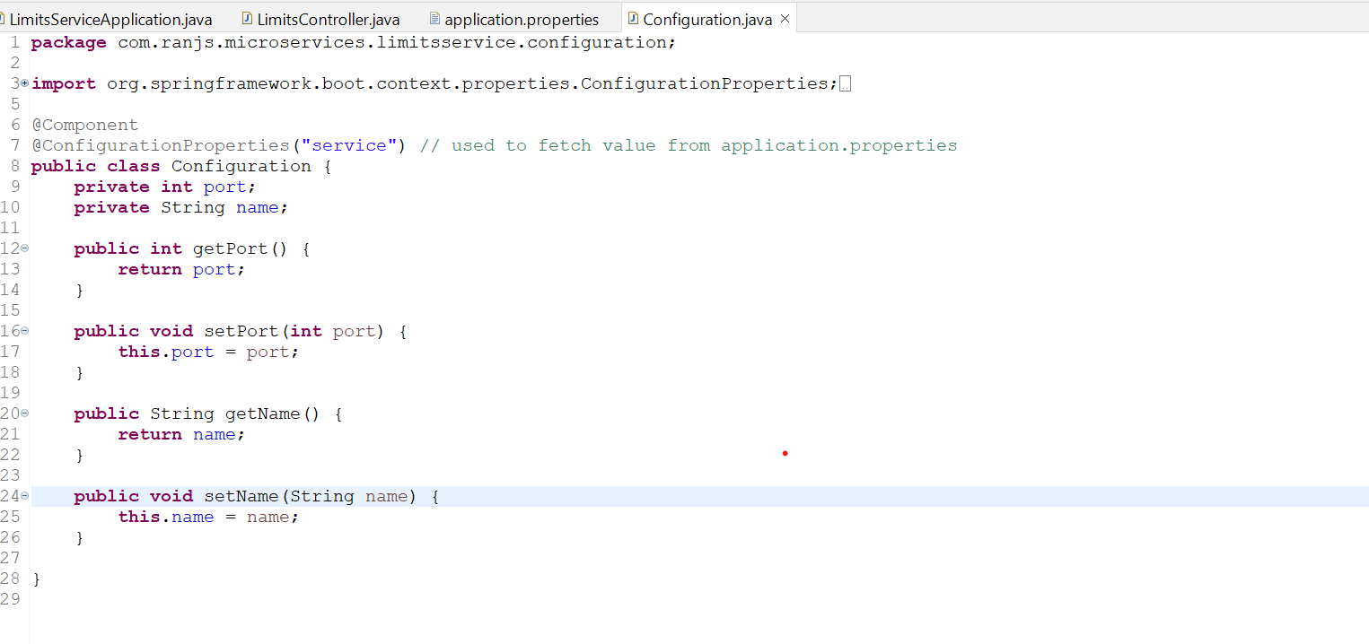

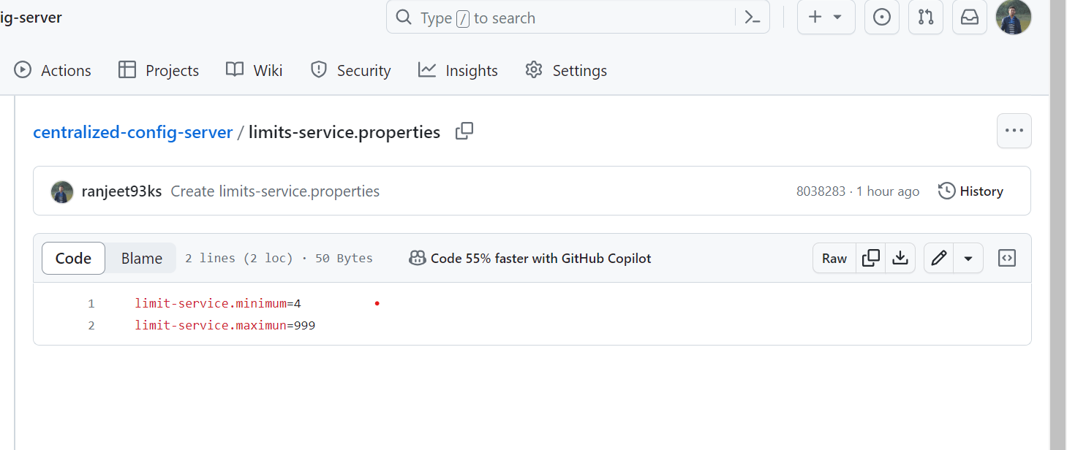

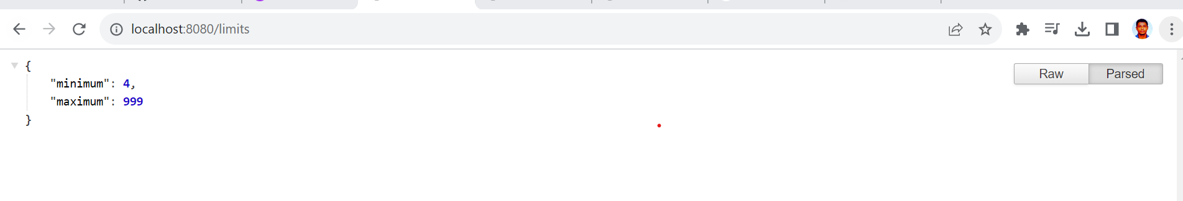

Create new properties files application-dev.properties and limits-service-dev.properties

When we will do spring.profiles.active=dev 🡪 values defined in dev files will hv more prefernces.

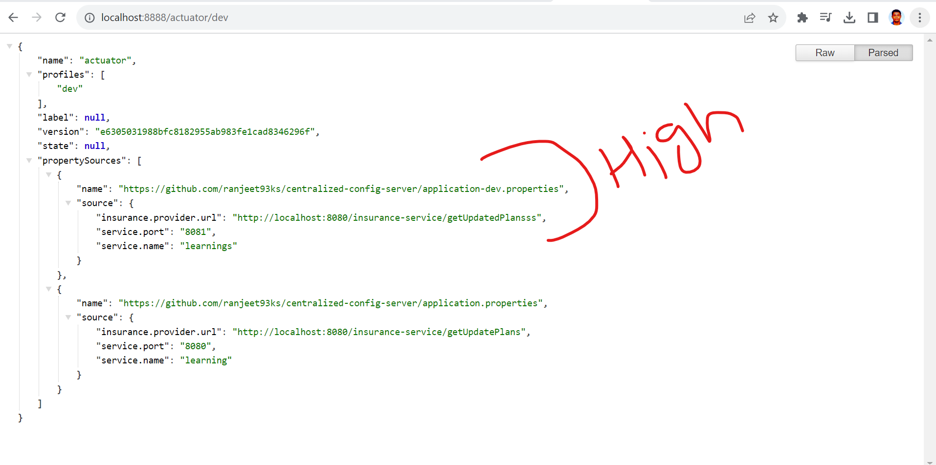

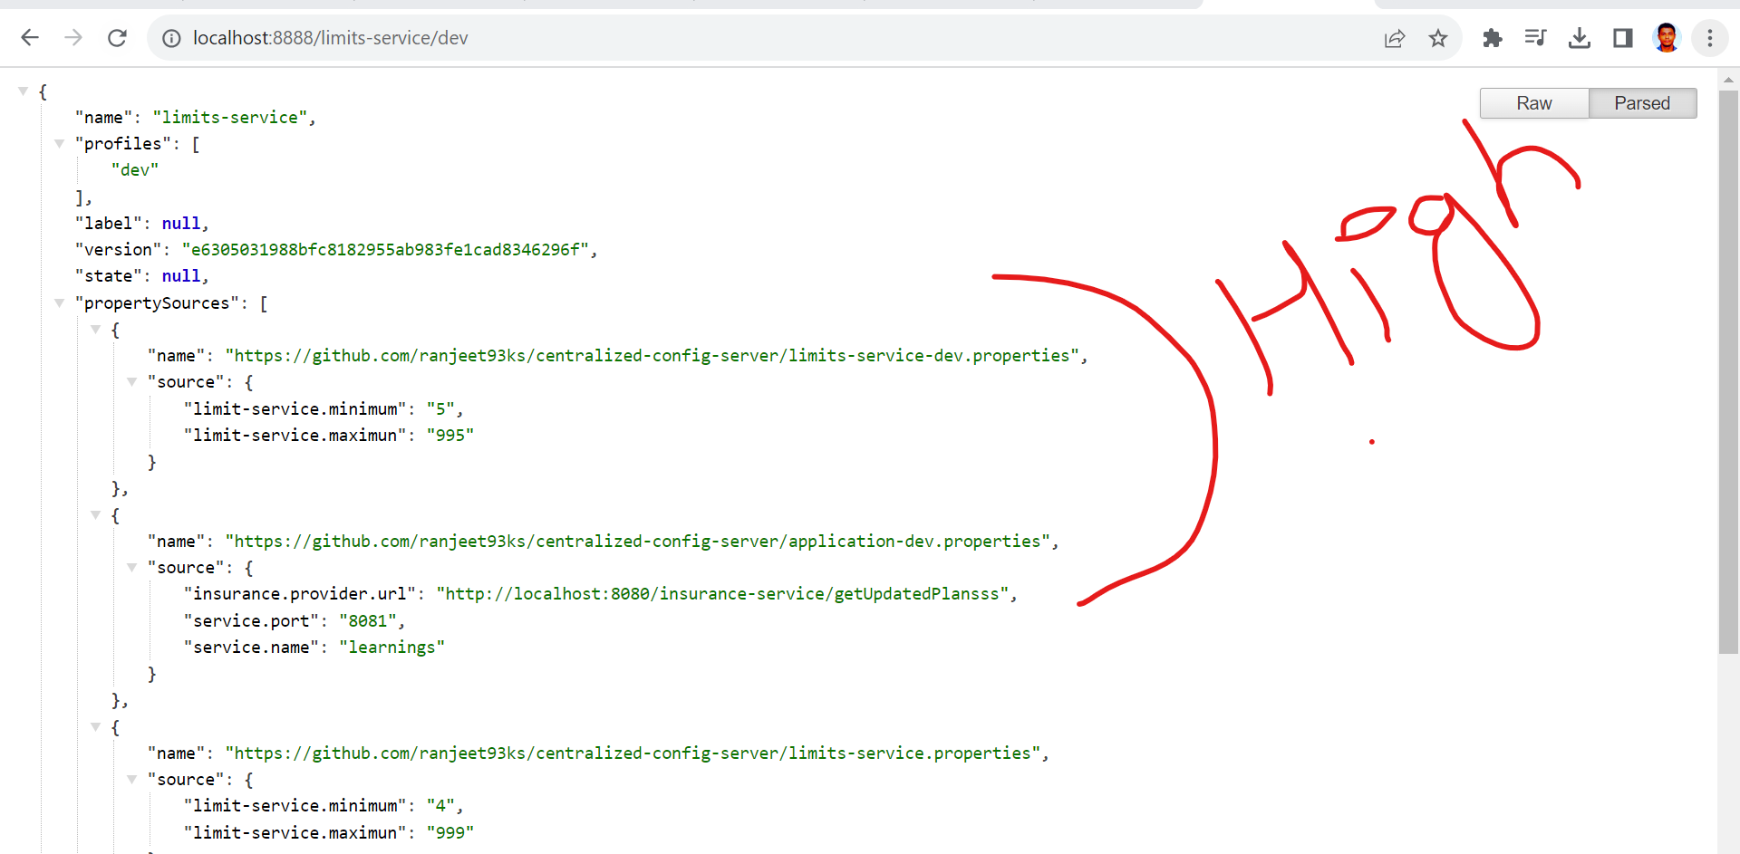

Now, values fetched from dev files

